ZS6BKW
It’s a design from ZS6BKW (aka G0GSF), similar to the G5RV, but it actually resonates on five bands, (well 6, actually) and doesn’t rely on a tuner (ATU) to make it work. The design appeared in TT (RadCom) Jan & Feb 1993, but is also in Pat Hawker’s “Antenna Topics” (publ. RSGB 2002) It’s only 90 ft long (27.51 metres), with a 40 ft (12.2 m) downlead.

Horizontal or inverted V layout
So, it’s a cousin to the G5RV (which only resonates on 14 & 24 MHz), but better as it needs no ATU on 40, 20, 17, 12, 10 and 6 meters.
Incidentally, all center fed antennas can be supported by just one mast, with the ends left to drop down. The ‘rule of thumb’ is that the angle at the apex should never be less than 90 deg, otherwise cancellation between the two halves occurs. Furthermore, as it is the current peaks along an antenna that do most of the radiation, having the center at the highest point is a positive advantage, rather than supported at each end with a big droop at the center (current point nearest to ground). This is another reason for not being too fussy about the ends of a center-fed antenna being lower or bent around. It will have minimal effect on radiation efficiency. The only thing is never having the ends dropping right down to ground level – because the ground will seriously de-tune the antenna and it will not work – believe me, I’ve tried it. Just a yard or so off the deck makes all the difference. Simply have end insulators (or plastic strips etc.), then wire or twine to the tying-off points. This effectively raises the ends of the antenna sufficiently clear of the ground. So, the ‘BKW can be horizontal (two supports) or inverted-vee layout (single support), as shown. Incidentally, the same applies to a simple dipole. The antenna wire can be solid copper, stranded, insulated or not.
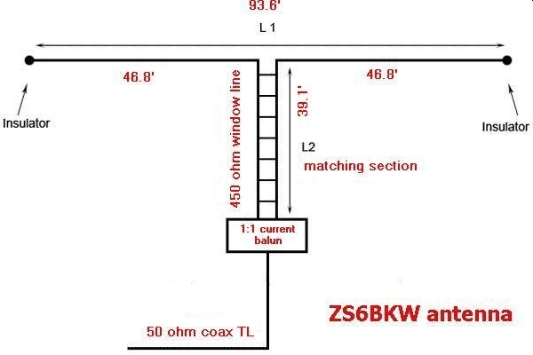
In the original design, 300 ohm twin was used, but I prefer the 450 ohm stuff. It’s much stronger and losses, especially in wet weather, are lower when impedances are high down the line. Back in 1985, 450 twin wasn’t readily available, there was only 75 and 300 twin, or the option of making your own open-wire feeders (which actually are the best of all – around 600 ohm, but these do tend to twist or get caught in trees etc! Yes – bitter experience and soldered joints here too!)
Finally, if you want to use it on other HF bands (3.5, 10, 21 MHz), an ATU (just like at the bottom of your ‘5RV!) will do the business, but preferably at the bottom of the 450 ohm feeder with a balanced output, not after a length of 50 ohm coax, if you’ve had to use it to reach your rig. Of course for 1.8 MHz (160m), you could short out the feeder twin, and feed it like a Marconi antenna, with a suitable ATU. Not very clever, however.
Here are the MFJ figures I recorded on the test antenna:-
Freq | SWR | “R” at feedpoint | Notes
3.38 MHz (80m) | 7:1 | 20 | ATU
7.00 MHz (40 m) | 1:1 | 40
10.1 MHz (30 m) | high | high | ATU
14.06 MHz (20 m) | 1:1 | 40 | l
17.85 MHz (17 m) | 1:1 | 50 | below 1.3:1 in 18MHz band
21.00 MHz (15m) | high | high | ATU
24.69 MHz (12 m) | 2:1 | 100 | ATU
28.62 MHz (10 m) | 1.3:1 | 60
50.27 MHz (6 m) | 1.3:1 | 60
Kevin VK2FUO advises to put a 1 to 1 current balun on the ZS6BKW antenna 450 ohm feeder line where it joins the 50 ohm coax to the radio.
VK2FUO acknowledges author Martyn G3UKV
W8TUZ acknowledges authors

