Construction
The antenna elements are made of 1/8" diameter stainless steel rod. Each rod is bent into a tight "U" shape and fastened to the acrylic plexiglass boom with stainless steel hardware. Flat washers large enough to fit across the gap in each element are used to hold the elements in place. A piece of 1/4" thick cast acrylic plexiglass, 18" long and 2-1/2" wide, is used for the boom.
Drill the holes in the boom as shown in the diagram. The position and hole size for the mast mounting clamp is determined by the size and width of the clamp or U-bolt that you use. I used a TV antenna mast clamp that fits a 1-1/4" mast.
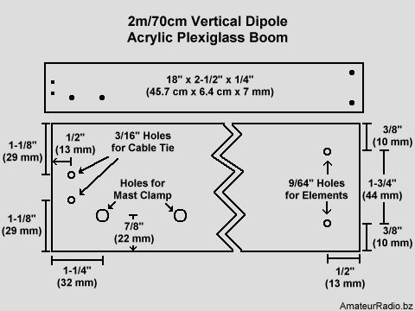
Probably the hardest part in making this antenna is bending the stainless steel rod. But the rod can be bent without heating it first with a torch. I was able to bend the rod by placing it in a bench vise. The tricky part is to bend two pieces of rod that come out looking similar is shape. Use two pieces of stainless steel rod that are longer than needed then trim them to correct lengths after the rod has been folded into a U shape. Make each element section as shown in the next diagram.

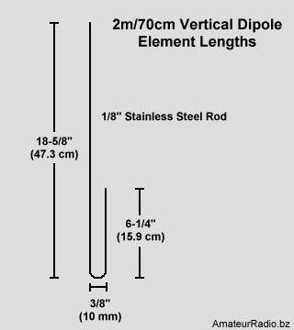
The hardware for mounting the antenna elements to the boom is also used to connect the feed line to the antenna. The coaxial cable center and shield are separated and the leads kept as short as possible. Crimp-on ring connectors, with the plastic insulation removed, are soldered to the ends of the cable. The coaxial cable center lead is connected to the top section and the shield is connected to the bottom section of the antenna. This antenna was fed with RG-8X (Mini 8) 50 ohm coaxial cable. The feed line used was a random length and was not cut to any specific length.
I used mostly all #6 stainless steel hardware to attach the antenna elements to the boom. Start by placing an external tooth lock washer on a machine screw then insert it into the hole drilled in the boom. Next install a flat washer, then the antenna element, then another flat washer. The ring connectors with the coaxial cable attached go on next then finally fasten with a split lock washer and a wing nut. Repeat for the opposite side.
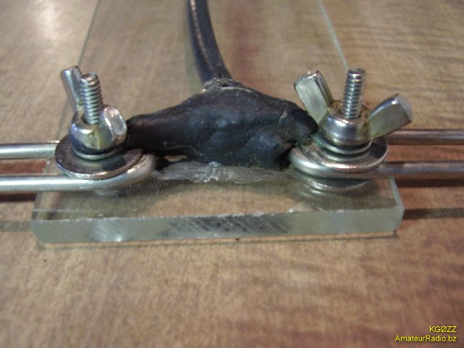
Tuning the Antenna
To tune the antenna for minimum SWR simply loosen the wing nuts and slide the antenna elements in or out as needed. Keep in mind that changes made to one band will affect the other band. For example if you shorten the 2 meter length then you also shorten the 70 cm length. Some fine tuning by again trimming either the 2 meter or 70 cm sections may be done if desired but this should not be needed.
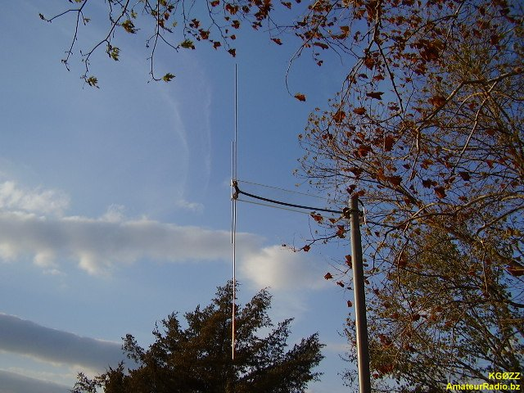
Parts List
All stainless steel element mounting hardware. Use larger size hardware if flat washers do not extend across both sides of the antenna element.
- 2 each 1/8" Stainless steel rod, 3' (.9 m) long.
- Acrylic Plexiglass, 18" x 2-1/2" x 1/4" (45.7 cm x 6.4 cm x 7 mm).
- 2 each #6 x 32 x 1" (25 mm) Machine screws.
- 2 each #6 x 32 Wing nuts.
- 4 each #6 Large flat washers.
- 2 each #6 Split lock washers.
- 2 each #6 External tooth lock washers.
- 2 each #6 Crimp-on ring connectors.
- Mast mount clamp.
- Plastic cable tie or small U-bolt.

